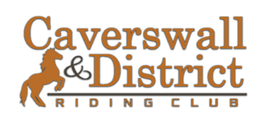
**ADVICE & TIPS**

We are a local friendly volunteer ran show and we aim to support and guide our competitors as much as possible to help them progress within all spheres of their riding and showing. We want to offer all our existing and potential new members free and best advice on being prepared for the show ring!
We are offering a guide to all to help whether you are complete new to showing or are looking for general guidance.
The committee of Caverswall and District Riding club work hard to help all our members and competitors out to ensure they have the best experience, should you have any questions or need advice then please do not hesitate to contact one of the committee members either via our Facebook page or email us at caverswallanddistrictrc@gmail.com
Please remember to enjoy your day, be polite and courteous to judges, stewards, competitors, and spectators!
FIRST IMPRESSIONS!!
As always first impressions always count! When entering the ring you and your horse / pony always want to be remembered for the right reasons and to stand out!
The overall picture should be safe, smart, appropriate, and comfortable.
SHOWING IS AN ART AND THE OVERALL PICTURE IS VERY IMPORTANT!
For riders in ANY class
- Jackets MUST be worn- see below for guidance on if Tweed or Navy is suitable for your class. (Jackets not required for beginners showing)
- Jodhpurs need to be light in colour- canary, fawn, beige or cream. White for dressage/show jumping only!
- Short Jodhpur boots in black or brown for children- don’t forget the jodhpur clips.
- Long boots in black or brown can be worn by teenagers or adults.
- Hair should always be neat and tidy and tied back.
- Gloves – for showing ideally brown/black or canary in colour.
- Showing cane- smart and appropriate – no schooling whips! No longer than 30 inches.
- Hats should always be worn to current safety standard and in accordance to CDRC show rules. Riding Hats – all handlers under the age of 16 MUST wear current standard riding hat in ALL in hand classes. All riders – retrospective of age or experience are to wear current standard hats.
- Jewellery- no earrings, piercings or visible jewellery should be worn for any classes. You will be asked to remove visible jewellery.
- Spurs – Spurs are not to be worn by riders aged 16 and under and should not be worn in novice/beginners classes.
Lead Rein classes of all type, including First Ridden
The same general advice as above applies or Riders in Lead Rein and First Ridden Classes.
Leaders in Lead Rein classes can also wear tweed jackets and trousers or skirts for ladies. The overall appearance must be smart, presentable, and practical- plus it is common courtesy for all handlers to wear a smart hat. For those competing in LEAD rein Working Hunter – Leaders are allowed to change to ‘faster’ footwear, but you remain in smart and presentable clothing – sorry no running gear!
Example of Lead Rein M&M
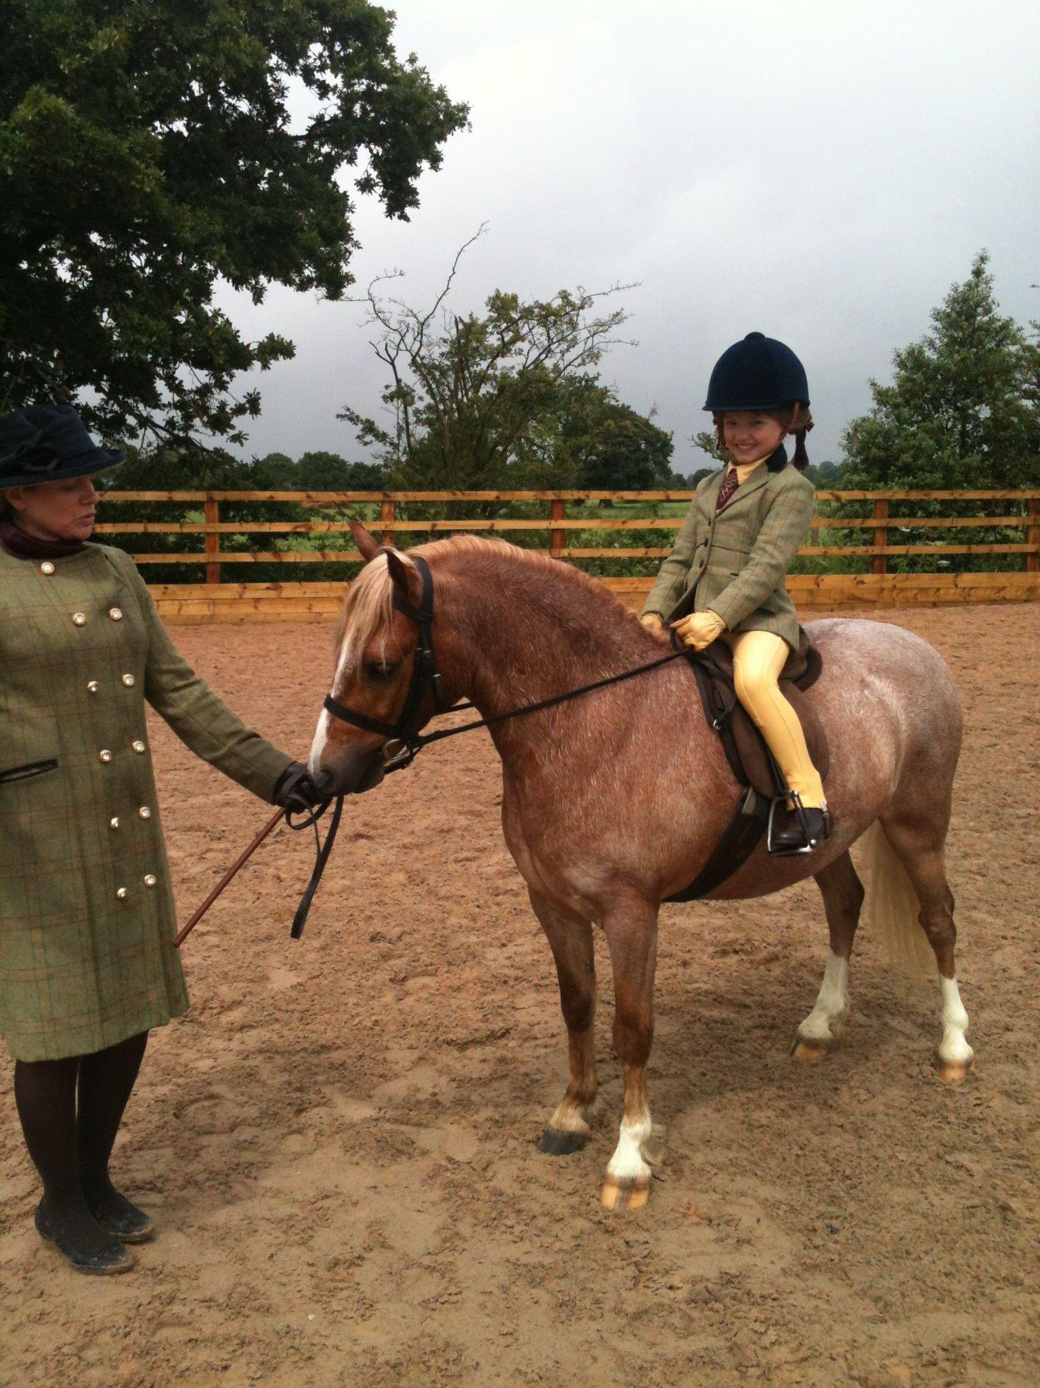
Remember in M&M is correct for the rider to be in tweed.
TOP TIP- Sensible shoes! Showgrounds are rarely flat and even- trainers are not ideal and not appropriate, so think about your footwear!

Example of Lead Rein Plaited
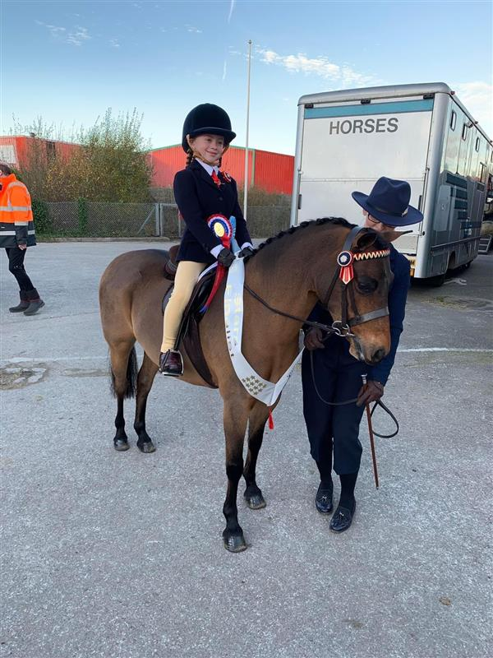

For lead rein classes where the pony is plaited the riser would normally wear a blue showing jacket – leader should also be suitably dressed and ideally coordinated with the rider.
Body protectors / Air Jackets can be worn in any class and will not be penalised.

M&M classes are for the following breeds- Shetland, Welsh A,B,C,D, New Forrest, Exmoor, Dartmoor, Dales, Highland, Fell & Connemara.
For M&M classes it is considered correct that riders will wear tweed jackets.
For those riding small breeds (all riders including seniors) i.e. Welsh A, B, Dartmoor, Exmoor and Shetland shirt jodhpur boots in black or brown should be worn.
For those riding large Breeds – long boots or jodhpur boots with gaiters should be worn.

Riding Horse Classes
Riders clothing stays the same for most showing classes.
The Show Pony equivalent is an Intermediate Show Riding Type, Show Hack or Riding Horse- in these classes riders should ideally be in Navy show jackets.
The show Hunter Pony bigger version is Ridden Hunter where riders should be in tweed.
Adult riders will wear long boots or short boots with gaiters in black or brown.
Junior Riders should wear short boots in black or brown.
Note in ridden flat classes horses / ponies should not be a in martingale and should not be wearing a flash noseband.
Working Hunter Classes
Note CDRC highly recommends the use of Body Protectors / Air Jackets- (Both juniors and Seniors) no one will be penalised for wearing one.
For riders in pony or horse classes tweed jackets are the normal dress code, and the general shirt, tie, light coloured jodhpurs or breeches.

In hand Classes
Handlers- Suit, Waistcoat, Smart Tweed or Navy jacket- dependant on type your showing.
Trousers or suitable Skirt
Shirt with collar and Tie.
Hat- Note all handlers under the age of 16 MUST wear current standard riding hat in ALL in hand classes. For adults Beagler hat, Bowler (men) or trilby type is appropriate.
Gloves – a safety and appropriate MUST.
Footwear- needs to be safe and practical- showgrounds are rarely flat and even.
Horse / Pony for in hand classes.
- Choose a bridle which suits your type of horse / pony
- If you are using the same bridle as you use for ridden classes – the rein(s) must be taken over the head.
- Control is very important when showing in hand. always think of safety and whether you can control your horse / pony.

TOP TIP- still unsure on what colour jacket?
Coloured Browband= Blue Jacket
Plain Browband = Tweed Jacket

What your best four legged friend should be wearing in the show ring!
General Rules
Tack- Saddle, Bridle, Girth and numnah can be black or brown (Havana).
It should always be clean and supple.
Make sure your tack fits!

Ridden Classes
Bridles
- A plant and workmanlike bridle is suitable for all classes.
- Novice Classes- should only ever be snaffle bit!
TOP TIP- Choose a bit that suits your horse / pony – if it goes well in snaffle then compete in snaffle- it’s a better image than animal not going well in a double / Pelham bridle.
Browbands
Plain Browbands- Show Hunter, Hunters, Cobs, Coloured Horses and Ponies, M&M
Coloured Browbands- ROR, show ponies, Show hacks, Riding Horses, Part Breeds.
Nose Bands
As with browbands the style of the noseband most suitable depends on your horse / pony type.
A flat, plain cavesson noseband will suit all types and is correct for Hunters, Cobs, WH, Show Hunters and M&M.
Finer head animals such as Hack, Riding Horse or Show pony may suit a slimmer thickness or a raised noseband.
Saddles
Ensure your saddle fits! And don’t ever forget your girth and stirrups!
General Purpose saddles can be used – other saddles types are
- Dressage
- Straight Cut Showing Saddles
- Jumping Saddles -for WH classes.
Numnahs
A neat fitting numnah which matches the colour of your tack is smart and professional.
Try not to use a saddlecloth as they take up to much space and stop the judge form seeing the best view of your best four legged friend!

Working Hunter
- Running Martingale are allowed in WH classes. All other tack should be the same as flat ridden showing classes.
- Brushing / protective boots in the ring for the jumping phase only. They should be removed after jumping ready for you to re enter the ring for the Show phase.

Novice Classes
- Snaffle bridles ONLY.
- Simple and appropriate noseband

M&M Classes
- Coloured Browbands are not worn in M&M classes

Lead Rein and First Ridden Classes
- Ponies should be in snaffle bridles ONLY.
- Lead Rein ponies ONLY- The Lead Rein MUST be attached to the noseband only.

In hand Classes
- Choose a bridle which suits your type of horse / pony
- If you are using the same bridle as you use for ridden classes – the rein(s) must be taken over the head.
- Control is very important when showing in hand. always think of safety and whether you can control your horse / pony.

